Name – Aditya Nayak

Reg Number – 21BCE0540

Number - +918976416016

Assignment 2 – roll dice with face of dice

Activity_main.xml code

<?xml version="1.0" encoding="utf-8"?>  
<LinearLayout  
 xmlns:android="http://schemas.android.com/apk/res/android"  
 xmlns:tools="http://schemas.android.com/tools"  
 xmlns:app="http://schemas.android.com/apk/res-auto"  
 android:orientation="vertical"  
 android:layout_width="match_parent"  
 android:layout_height="match_parent"  
 android:gravity="center"  
 tools:context=".MainActivity">  
  
  
 <ImageView  
 android:id="@+id/faceimageView"  
 android:layout_width="256dp"  
 android:layout_height="216dp"  
 android:layout_marginBottom="16sp"  
 android:src="@drawable/one" />  
  
 <TextView  
 android:id="@+id/resulttextView"  
 android:layout_width="wrap_content"  
 android:layout_height="wrap_content"  
 android:layout_marginBottom="16sp"  
 android:text="result is shown here"  
 android:textSize="24sp" />  
  
 <Button  
 android:id="@+id/rollbutton"  
 android:layout_width="wrap_content"  
 android:layout_height="wrap_content"  
 android:text="roll dice"  
 android:textSize="20sp" />  
  
</LinearLayout>

MainActivity.kt code

package com.example.assignment2  
  
import android.annotation.SuppressLint  
import android.os.Bundle  
import android.widget.Button  
import android.widget.TextView  
import android.widget.ImageView  
import androidx.activity.ComponentActivity  
  
  
import java.util.*  
  
class  
MainActivity : ComponentActivity() {  
 private lateinit var resulttextView: TextView  
 private lateinit var rollbutton: Button  
 private lateinit var faceimageView: ImageView  
  
  
 @SuppressLint("MissingInflatedId")  
 override fun onCreate(savedInstanceState: Bundle?) {  
 super.onCreate(savedInstanceState)  
 setContentView(R.layout.*activity_main*)  
  
 resulttextView = findViewById(R.id.*resulttextView*)  
 rollbutton = findViewById(R.id.*rollbutton*)  
 faceimageView = findViewById(R.id.*faceimageView*)  
  
  
 rollbutton.setOnClickListener **{** rollDice()  
 **}** }  
 private fun rollDice() {  
 val randomnumber = Random().nextInt(6) + 1  
 val resultText = "You rolled a $randomnumber"  
 resulttextView.*text* = resultText  
  
 val drawableResource = when (randomnumber) {  
 1 -> R.drawable.*one* 2 -> R.drawable.*two* 3 -> R.drawable.*three* 4 -> R.drawable.*four* 5 -> R.drawable.*five* else -> R.drawable.*six* }  
  
 faceimageView.setImageResource(drawableResource)  
 }  
}

Drive Link - <https://drive.google.com/drive/folders/1UgSHkc5JdCsRGYlL-dhHxE-3dRnYBclb?usp=sharing>

Output Screenshots

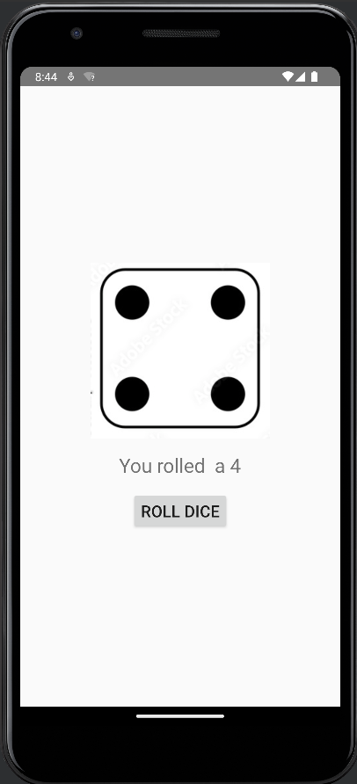 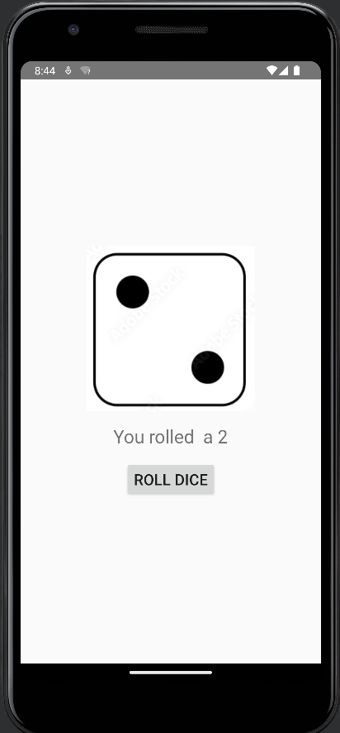 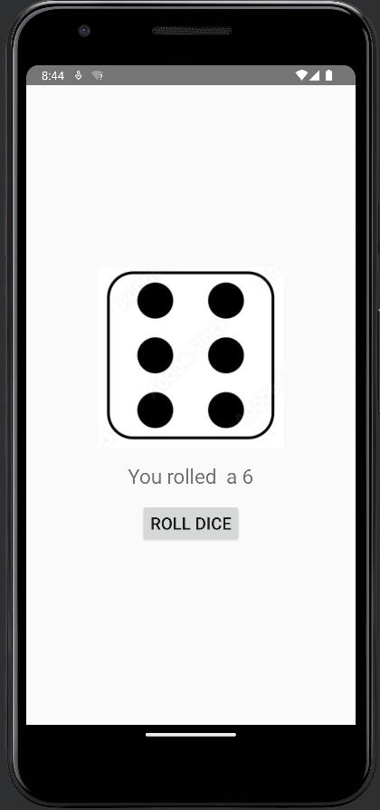

1st roll 2nd roll 3rd roll